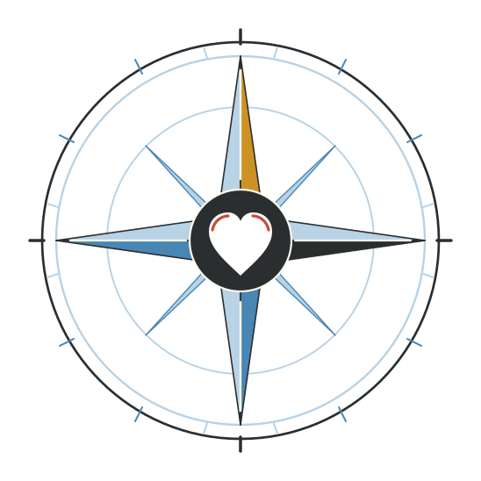

Angela Rose Harris
MEDIA AND PRESS KIT
AUTHOR | SPEAKER | NEAR-DEATH EXPERIENCER
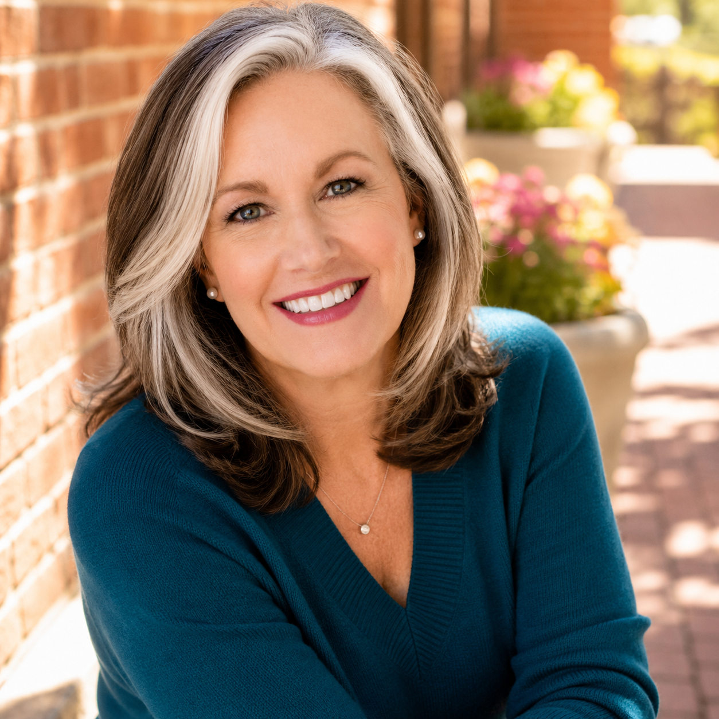
Exploring extraordinary spiritual experiences and what they reveal about consciousness, love, and how we are called to live.
angelaroseharris.com | emailangelaharris@gmail.com
Updated September 2026

At a Glance
Angela Rose Harris brings a rare combination of firsthand experience, grounded spiritual care, organizational leadership, and editorial judgment to conversations about death and consciousness.
In 2015, Angela's heart stopped during a hospital tilt-table test. She returned with detailed memories of an experience that included a peaceful black void, awareness beyond the body, reunion with deceased loved ones, a life review, possible futures, and an expanded sense of identity. Her work now focuses on what extraordinary experiences mean for the way we live, love, grieve, and care for one another.
“Leaving my body did not erase Angela. I did not survive as a blank point of consciousness. I survived as myself.”
QUICK FACTS
FACT | DETAIL
Public name | Angela Rose Harris
Based in | The foothills of the Appalachian Mountains in North Carolina
Primary roles | Author, international speaker, spiritual director, spiritual emergence coach, and near-death experiencer
IANDS leadership | Board Member, Director of Groups and Events, and IANDS Certified Facilitator
Editorial role | Managing Editor of Vital Signs, the IANDS quarterly magazine
Professional background | Former elementary school teacher; BAEd
Core subjects | Near-death experiences, consciousness, life after death, spiritual emergence, integration, grief, identity, and love

Current Book
Will I Still Be Me? | Coming December 2026
The forthcoming book explores 15 questions organized around three fears: Will I still exist? Will I suffer? Will I remember my life and the people I love? Angela offers no universal doctrine; she shares what happened when her heart stopped and what the experience revealed about consciousness, suffering, and the bonds we share.

The Story and the Perspective

The Medical Event
During a hospital test in 2015, Angela's heart stopped for approximately 30 to 32 seconds. Medical staff worked to stabilize her while her husband witnessed the crisis. The event became a dividing line in her life: before it, she was an elementary school teacher and mother trying to keep up with a body that was increasingly difficult to trust; after it, she had to find language for an experience that felt more real than ordinary reality.

What She Remembers
- A peaceful, velvety black void and a sense of waking up dead.
- Awareness beyond the body, including seeing, hearing, and knowing what was happening in the room.
- Reunion with deceased relatives and friends and an overwhelming experience of love and homecoming.
- A life review, access to knowledge, and a radically different experience of time.
- Possible futures for her children and a larger sense of identity that included other lives and nonhuman forms.
- A return to the body followed by years of spiritual emergence, questioning, integration, and service.

The Grounded Throughline
Angela speaks about extraordinary experiences without asking audiences to adopt a belief system. She distinguishes what happened to her from what she can prove for others, honors medical care, and makes room for scientific uncertainty. Her emphasis is practical: if consciousness and love are larger than we assume, how should that change the way we live now?
QUOTABLE LINES
“The medical equipment could measure what happened to my body, but it could not measure what happened to me.”
“I was becoming aware of a larger soul identity, but Angela had not disappeared inside it.”
“What if awakening is not about becoming someone new, but remembering who you are?”

Approved Biographies
SHORT BIO APPROXIMATELY 55 WORDS
Angela Rose Harris is an author, international speaker, spiritual director, and near-death experiencer. During a 2015 hospital test, her heart stopped for approximately 30 to 32 seconds. She now helps audiences explore what extraordinary spiritual experiences reveal about consciousness, identity, love, and the way we are called to live.
MEDIUM BIO APPROXIMATELY 110 WORDS
Angela Rose Harris is an author, international speaker, Certified Spiritual Director, Spiritual Emergence Coach, and near-death experiencer. During a hospital test in 2015, her heart stopped for approximately 30 to 32 seconds. She returned with memories of awareness beyond the body, reunion with deceased loved ones, a life review, possible futures, and a larger sense of identity. Angela serves as an IANDS Board Member, Director of Groups and Events, IANDS Certified Facilitator, and Managing Editor of Vital Signs. A former elementary school teacher, she brings warmth, clarity, and practical grounding to conversations about death, consciousness, spiritual transformation, grief, and love.
FULL BIO APPROXIMATELY 230 WORDS
Angela Rose Harris is an author, international speaker, Certified Spiritual Director, Spiritual Emergence Coach, and near-death experiencer whose work bridges extraordinary spiritual experience with the ordinary demands of being human. During a hospital tilt-table test in 2015, her heart stopped for approximately 30 to 32 seconds. She returned with detailed memories of a peaceful black void, awareness beyond the body, reunion with deceased loved ones, a life review, possible futures, and a larger identity that did not erase the person she had been.
The years that followed were not a simple return to normal. Angela had to integrate profound changes in identity, purpose, relationships, and belief while remaining a mother, wife, and working professional. That experience shaped her grounded approach: she does not ask people to accept a doctrine or abandon critical thinking. She invites them to consider what experiences at the edge of life may reveal about consciousness, suffering, love, and how we care for one another.
Angela is an IANDS Board Member, Director of Groups and Events, IANDS Certified Facilitator, and Managing Editor of Vital Signs. She has helped expand supportive spaces for people navigating near-death and other spiritually transformative experiences. A former elementary school teacher with a BAEd, she is based in North Carolina. Her forthcoming book, Will I Still Be Me?, explores 15 questions about death through the perspective of someone who died and came back.

Speaking and Interview Topics
Will I Still Be Me?
What a near-death experience revealed about continuing identity, memory, personality, and love after the body stops.
Thirty-Two Seconds and a Lifetime of Integration
The medical event, the experience beyond the body, and the years of change that followed the return.
What Death Could Not Measure
A grounded conversation about the limits of medical measurement, the brain-as-filter possibility, and why intellectual humility matters.
The Three Questions Beneath Our Fear of Death
Will I still exist? Will I suffer? Will I remember my life and the people I love? A humane framework for conversations people often feel unsafe having.
When a Spiritual Experience Disrupts a Human Life
How spiritual emergence can affect identity, relationships, work, belief, and mental health - and what safe integration support looks like.
Love After the Life Review
Why love is more than a comforting message from the other side and what it asks of us in daily choices, relationships, and service.
Consciousness Beyond the Familiar
Parallel lives, nonhuman forms, multidimensional identity, and how to discuss unusual experiences without sensationalizing them.
Creating Safe Communities for Extraordinary Experiences
Lessons from building and leading peer support, training facilitators, and helping experiencers move from isolation to connection.

Audience Fit
General-interest media | Book and author podcasts | Spirituality and consciousness programs | Grief and bereavement communities | Healthcare and helping professionals | NDE and afterlife audiences | LGBTQ+ affirming conversations | Leadership and community-building events

Suggested Interview Questions
1. What happened medically during the hospital test in 2015, and what do you remember experiencing?
2. You say that leaving your body did not erase Angela. What remained recognizably you?
3. How did time feel during the experience compared with the time recorded in the hospital?
4. What did the life review teach you about the way our choices affect other people?
5. How did encounters with deceased loved ones change your understanding of grief and connection?
6. You were shown possible futures for your children. How did that affect you as a mother when you returned?
7. Your experience included other lives and nonhuman forms. How do you talk about those memories without asking people to believe you?
8. What was harder: the medical event itself or learning how to live afterward?
9. How can someone distinguish spiritual emergence from a mental health crisis, and when should professional care be involved?
10. What do families and clinicians often misunderstand about people who report near-death or other spiritually transformative experiences?
11. Your book asks whether we still exist, suffer, and remember the people we love. Why do those three questions sit beneath so many fears about death?
12. What does it mean to rise toward love in ordinary life - at work, in families, and in moments when love is difficult?
13. How has your background as an elementary school teacher shaped the way you explain complex spiritual experiences?
14. What has your work with IANDS taught you about the patterns shared across many experiencers?

Host Introduction
Today's guest is Angela Rose Harris, an author, international speaker, Certified Spiritual Director, and near-death experiencer. During a hospital test in 2015, her heart stopped for approximately 30 to 32 seconds. She returned with memories of awareness beyond the body, deceased loved ones, a life review, possible futures, and a larger sense of identity. Angela is an IANDS Board Member, Director of Groups and Events, Certified Facilitator, and Managing Editor of Vital Signs. Her forthcoming book is Will I Still Be Me?

Selected Media Appearances
Click any title to watch or listen. Titles below follow the public program listings.
PROGRAM | APPEARANCE
IANDS | She Died for 32 Seconds - Then She Remembered Everything: Multidimensional Parallel Lives and More
IANDS | NDE with Non Human Beings and LGBTQ Vision with Angela Harris
JeffMara Podcast | She Died and Met Her Soul Family on the Other Side
WTF Just Happened?! | Knowing Her Kids' Future with Near Death Experiencer and IANDS Board Member Angela Harris
The Soul Inspired | Woman Died, Saw Possible Future Events and How We Live Many Lives
Every Soul Knows | Angela Harris - Near-Death Experiencer and IANDS Director of Groups and Events
The Other Side NDE | Teacher Dies; Sent to Velvety Void Where Souls Plan Their Earth Journeys
YouTube | Additional interview with Angela Rose Harris
AJ Parr Spiritual Journalist | Woman Dies; Discovers We're Living Parallel Lives on Other Planets
The Soul Inspired | Near Death Experiencer Talks UFO and NDE Connection
Dani Foffa | Teacher Dies and Meets Life Guide and Multidimensional Parallel Lives During Incredible NDE

Selected Writing and Editorial Work
Angela writes at the intersection of experience, research, spiritual practice, community care, and public education. These selected pieces appeared in Vital Signs, the quarterly magazine of the International Association for Near-Death Studies.
SEPTEMBER 2025 Together, We Heal. Together, We Learn. Together, We Grow.
IANDS support, education, research, and the role of safe community after extraordinary experiences.
DECEMBER 2025 What Lies Beyond Death? Dr. Marina Weiler on the Science of Extraordinary Human Experiences
An in-depth interview on consciousness research at the University of Virginia Division of Perceptual Studies.
SPRING 2026 Life, Rewritten: Renewal After a Near-Death Experience
How NDE aftereffects reshape work, relationships, values, time, and the long process of integration.
SPRING 2026 Kimberly Clark Sharp of Seattle IANDS
A conversation about launching the first Seattle IANDS local group and the power of showing up for experiencers.
JUNE 2026 Embodied Awakening: Nondual Realization Through Classical Tantra
A grounded introduction to recognition, embodiment, and the sacredness of ordinary life.
JUNE 2026 Biofield Breakthrough: Where Energy and Oncology Converge
A research-informed look at Reiki in oncology, from symptom relief to emerging biological questions.
JUNE 2026 The Power of Presence: How In-Person Conversations Change Lives
An interview-based feature on IANDS Greensboro and why face-to-face community matters after spiritually transformative experiences.

Editorial Perspective
As Managing Editor of Vital Signs, Angela translates complex and sometimes controversial subjects into clear, humane stories. Her editorial work reflects the same balance she brings to interviews: respect for firsthand experience, attention to evidence, and care with claims that cannot be generalized beyond the person reporting them.

Credentials and Contact

Professional Roles
- Board Member, International Association for Near-Death Studies
- Director of Groups and Events, IANDS
- Managing Editor, Vital Signs
- IANDS Certified Facilitator and trainer
- Certified Spiritual Director
- Spiritual Emergence Coach
- Adult near-death experience group leader
- Former elementary school teacher, BAEd

What Angela Offers Media
- A detailed firsthand account that can be adapted for short interviews or long-form conversation.
- A grounded, non-dogmatic approach that welcomes skepticism and careful questions.
- Professional insight into integration, peer support, facilitator safety, and community care.
- Experience discussing grief, LGBTQ+ family concerns, nonhuman encounters, and unusual spiritual phenomena with warmth and clarity.
- Strong camera and podcast experience across intimate, educational, and investigative formats.

Booking and Media Inquiries
Email emailangelaharris@gmail.com
Website www.angelaroseharris.com
LinkedIn Angela Rose Harris
Facebook Angela Rose Harris NDE

Rise Toward Love
Rise Toward Love is Angela's author and spiritual platform: letters about consciousness, love, and being human. The guiding idea is that awakening is not an escape from human life, but a deeper way of inhabiting it.
Warm. Alive. Human. Intelligent. Trustworthy. Luminous.

